

**硕士研究生学位论文**

**中期检查报告**

**Mid-Term Inspection Report of Graduate Student Degree Thesis**

**Thesis Title:** Spatial and Temporal Characteristics of Passenger

Ship Emission Inventory Based on AIS Data

**College:** Maritime College

**Major:** Transportation Engineering

**Research Field:** Traffic Information Engineering and Control

**Name:** Xu Xubao

**Student ID:** 2211120015

**Supervisor:** Feng Hongxiang

**Enrollment Date:** 2024.09

Ningbo University Maritime College

July 2024

**Instructions of Mid-Term Inspection Report for Master's Thesis**

1. The mid-term progress report of a master's thesis is the foundation for ensuring the quality of the thesis. In order to improve the process management system of the master's degree and enhance the quality of the master's degree, it is required that current master's students must conduct comprehensive scientific research work after the proposal is approved. In principle, the mid-term progress report of the thesis should be completed before the end of the fourth semester.

2. The mid-term progress report of the thesis should be completed by the graduate student themselves under the guidance of the supervisor (group). The main text of the mid-term progress report should have a word count of 8000 to 10000 words, and should be logically rigorous, with clear and understandable sentences, and standardized chart formats.

3. After completing the "Mid term Examination Report for Master's Thesis" and being reviewed and approved by the supervisor, master's students should hold a public mid term examination report meeting for their thesis within their own discipline or related disciplines.

4. The mid-term assessment report will be organized and implemented by the master's student enrollment discipline. The mid-term assessment team is responsible for filling out conclusive review opinions and filing the results and relevant materials with the study abroad institution. The mid-term assessment team is composed of 3-5 experts from relevant disciplines, with one team leader and one secretary each. The applicant's supervisor cannot be a member of the assessment team. The members of the mid-term assessment team for master's thesis are recommended to be consistent with the members of the opening report review team.

5. The mid-term inspection report for master's thesis must be printed on double-sided A4 paper and bound into a volume on the left side. If there are not enough spaces in each column, please add pages by yourself.

**Table of Contents**

1 Research Content 1

2 Research Progress, Completed Research Content and Achievements 2

2.1 Research Progress 2

2.1.1 Thesis Outline 2

2.1.2 Current Progress 3

2.2 Completed Research Content 3

2.2.1 Emission Estimation and Correction for Meteorological Factors 3

2.2.2 The overall distribution of passenger ships in the Zhoushan area 5

2.2.3 June-December 2020 Passenger Ship Emission Inventory 5

2.2.4 Emission Distribution Across Different Time Periods 6

2.2.5 Different types of passenger ships' contribution to emissions 6

2.2.6 The emission share of passenger ships in different operational modes 7

2.2.7 The impact of adverse weather conditions 8

2.2.8 Passenger ship trajectory distribution 8

2.2.9 Spatial Distribution of Passenger Ship Emissions 9

2.3 Current Research Achievements 10

3 Expected Problems and Solutions 11

3.1 Current and expected issues that may arise 11

3.2 Solution 11

4 Next Step Work Plan 12

References 13

# 1 Research Content

This study aims to establish a passenger ship atmospheric pollutant emission calculation model with regional characteristics. By using AIS data and the technical specifications of ship construction, the study will create an emission inventory and report on the spatiotemporal distribution characteristics, and finally propose scientific emission reduction measures and suggestions based on the research results. The main research content includes:

(1) Constructing a passenger ship atmospheric pollutant emission estimation model based on the characteristics of ship activities, by reviewing and analyzing domestic and international methods for estimating ship atmospheric pollutant emissions, and determining that this study will use a bottom-up approach to estimate emissions from port ships, referring to relevant literature to construct a regional passenger ship emission estimation model.

(2) Constructing a passenger ship atmospheric pollutant emission inventory based on AIS data, selecting Ningbo Zhoushan Port area as the main area, determining representative regions and boundaries, obtaining AIS data for all ships in the area within the specified time, preprocessing data, parsing AIS messages, removing invalid data, matching with ship static information from ship-related databases and relevant maritime departments, then performing meteorological data speed correction to obtain relatively complete data for the area and establish a study area atmospheric pollutant emission inventory.

(3) Conducting visualization research on atmospheric pollutant emissions from port passenger ships. For the above estimation results, analyze the contribution rate of ship pollutant emissions from the perspectives of ship navigation conditions and emission sources. Then, conduct spatiotemporal visualization distribution research, including time visualization analysis of port passenger ships by month and time to explore emission patterns over time; spatial visualization analysis mainly involves dividing the research area into high-resolution grids, linking various atmospheric pollutant emissions of ships with their navigation trajectories using latitude and longitude information in AIS data, calculating the pollutant emissions in each grid, and depicting the spatial distribution of passenger ship pollutant emissions with heat maps, analyzing the spatial distribution patterns of ships in the area based on geographical features.

# 2 Research Progress, Completed Research Content and Achievements

## 2.1 Research Progress

### 2.1.1 Thesis Outline

1.Introduction

1.1 Research Background and Significance

1.1.1 Research Background

1.1.2 Research Significance

1.2 Research Status Domestic and Abroad

1.2.1 Current Status of Ship Emission Research

1.2.2 Top-Down Method

1.2.3 Bottom-Up Method

1.3 Main Content and Organizational Structure of the Research

1.3.1 Research Content

1.3.2 Research Approach

1.3.3 Main Innovations of the Research

1.3.4 Thesis Structure

1.4 Summary of This Chapter

2. Introduction to AIS System and AIS Data

2.1 Automatic Identification System (AIS)

2.2 AIS Data

2.3 Decoding of AIS Messages

2.4 Summary of This Chapter

3. Method for Establishing AIS-Based Passenger Ship Emission Inventory

3.1 Overall Framework for Establishing AIS-Based Passenger Ship Emission Inventory

3.2 Bottom-Up Method

3.3 Data Sources and Description of Passenger Ships

3.4 Meteorological Environmental Data Processing

3.4.1 Wind Data

3.4.2 Wave Data

3.4.3 Current Data

3.4.4 Ship Speed Correction

3.5 Processing of Passenger Ship Dynamic Information

3.6 Calculation and Spatial Representation of Passenger Ship Emissions

3.6.1 Calculation of Passenger Ship Emissions

3.6.2 Statistical Representation of Regional Passenger Ship Exhaust Emissions

4.AIS Data-Based Emission Inventory of Passenger Ships in Zhoushan Area

4.1 Research Area

4.2 AIS Data Processing

4.2.1 Area Filtering

4.2.2 Data Cleaning

4.2.3 Emission Factors and Load Factors

4.2.4 Fuel Correction Coefficients

4.3 Emission Inventory of Passenger Ships in Zhoushan Area

4.3.1 AIS Information Statistics

4.3.2 Passenger Ship Statistics

4.3.3 Emission Inventory

4.4 Summary of This Chapter

5. Spatiotemporal Characterization and Analysis of Passenger Ship Emissions in Zhoushan Area

5.1 Temporal Distribution of Passenger Ship Emissions

5.1.1 Impact of Meteorological Environment on Temporal Distribution

5.1.2 Impact of Different Time Periods on Emission Distribution

5.1.3 Impact of Different Types of Vessels on Emission Distribution

5.2 Spatial Distribution of Passenger Ship Emissions

5.2.1 Spatial Distribution of Emissions on Different Routes

5.2.2 Spatial Distribution of Emissions Between Zhoushan Islands

5.3 Study on Emission Reduction Strategies for Passenger Ships

5.4 Summary of This Chapter

6. Conclusion and Prospects

6.1 Conclusion

6.2 Prospects

References

Acknowledgements

### 2.1.2 Current Progress

The core of the thesis, Chapters 3 and 4, has been completed to date.

## 2.2 Completed Research Content

### 2.2.1 Emission Estimation and Correction for Meteorological Factors

In the bottom-up method, parameters such as ship characteristic data and variations in the power model have a relatively high impact on emission estimation. Additionally, under sailing conditions, the motion state is affected by meteorological and hydrological environments such as wind, waves, and currents, leading to a decrease in sailing speed, known as speed loss. Speed loss is not only related to the ship's tonnage, draft, and hull shape but also to the cargo characteristics. Therefore, the impact of wind, waves, and currents on ships needs to be corrected.

The ship speed shown in AIS data usually refers to the ship's speed relative to the water, without considering the effects of wind, current, waves, and other external factors. These external factors can cause a loss of ship speed. To more closely match the actual load of the passenger ship and to make the estimation results more accurate, it is necessary to correct the ship's sailing speed to obtain the true sailing speed of the ship. The sailing speed of the ship before being affected by wind, current, and waves is equal to the sailing speed provided by AIS minus the wind drift speed, current drift speed, and wave drift speed. The ship speed correction process is as follows:

(2.1)

By orthogonal decomposition, Equation 1 can be decomposed as:

(2.2)

Where: represents the ground speed;

represents the engine output speed after reduction;

represents the wind-induced drift speed;

represents the current speed;

and are the rectangular components of the speed;

is the flow angle between and at time t;

is the relative bearing between andat time t;

Further processing of the formula yields the detailed formula for :

(2.3)

In the end, after correcting for the effects of the wave factor, the original speed output of the ship's engine, is obtained.

(2.4)

Where： is the significant wave height;

is the relative bearing;

is the actual displacement of the ship;

*，，，* are the ship's performance parameter values,

with =0.745，=0.05015，=0.0045，=1.35*106.

*G* is an empirical coefficient dependent on the ship's displacement . The relationship between the two parameters is illustrated in the following figure:

（2.5）

The aforementioned model can calculate the true engine output speed of a ship given AIS data and information on wind, waves, and currents in the navigation area, thereby enabling accurate estimation of ship emissions.

### 2.2.2 The overall distribution of passenger ships in the Zhoushan area

At present, this paper has completed the emission estimation of Zhoushan passenger ships for the period from June to December 2020, and the overall situation of the passenger ships is as follows: Within the time frame, a total of 576 ships were selected through the ship type screening in the AIS data of the Ningbo Zhoushan area. After ship screening and error information verification, 153 short-distance passenger ships operating in the Zhoushan area were obtained, which is quite consistent with the data registered by the competent department. The AIS data information sent by them accounts for 95.64% of the AIS data of the passenger ships in the area. Passenger ships are divided into regular passenger ships, roll-on/roll-off passenger ships, high-speed passenger ships, and car and passenger ferries, with their average main engine power being 994.3 kW, 1902.8 kW, 1936 kW, and 356.4 kW respectively; the average passenger capacity is 370.4 people, 337.2 people, 149.6 people, and 106.4 people respectively. The distribution of the construction years of the main engines of the passenger ships is shown in Figure 2.1.

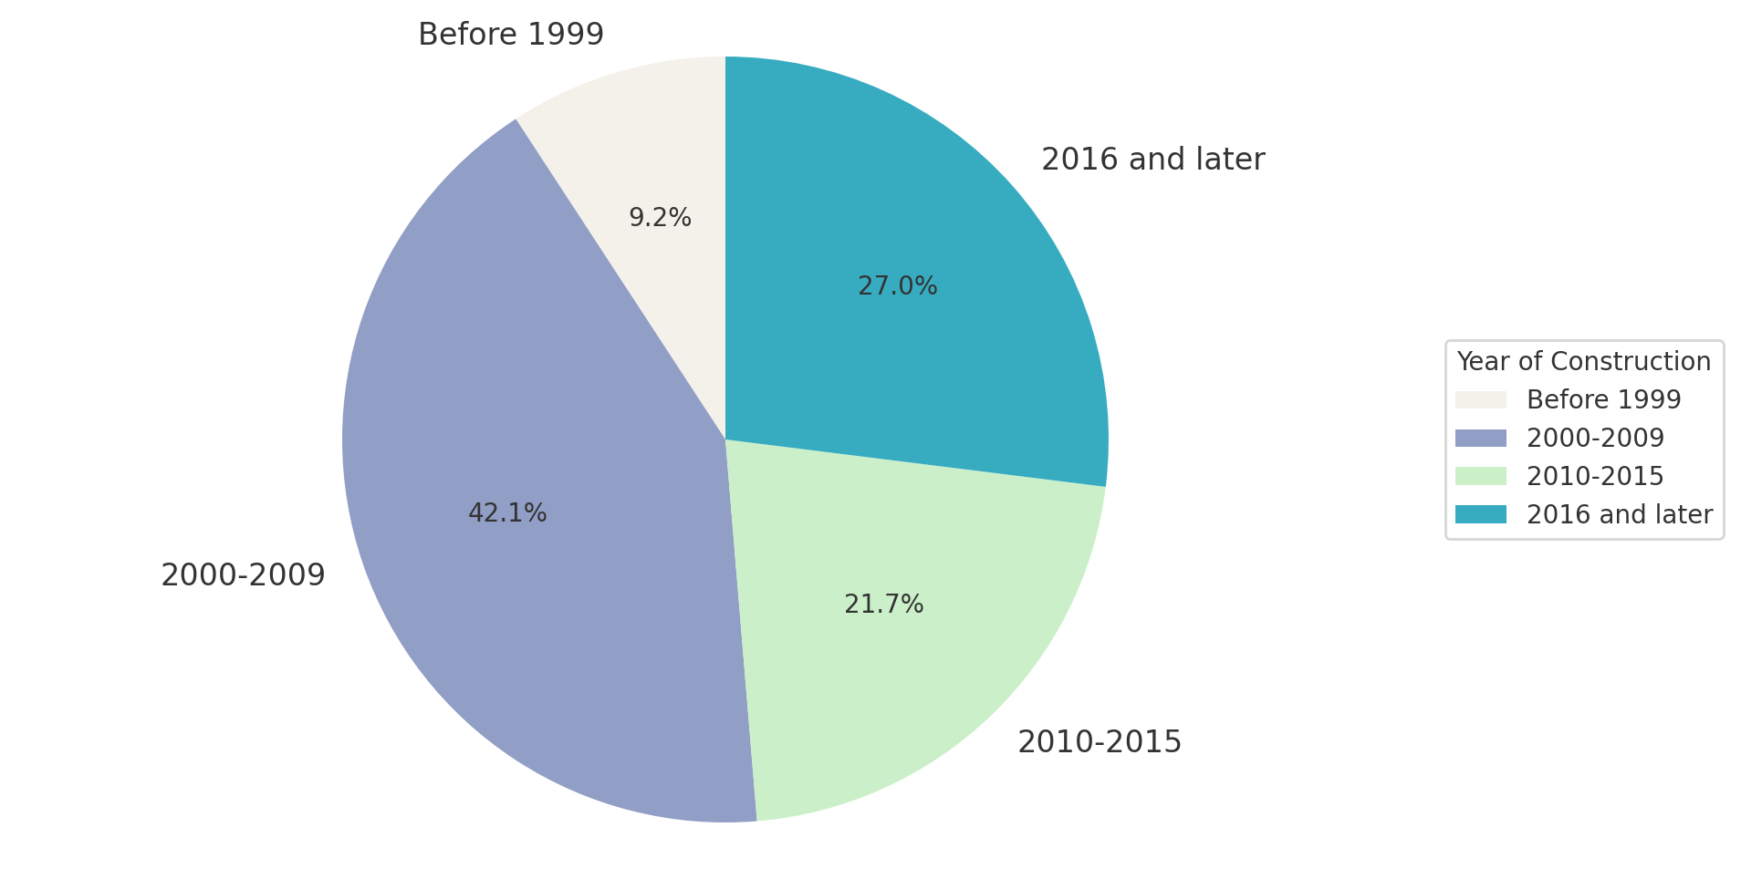

Figure 2.1 Distribution of Passenger Ship Main Engine Construction Years

### 2.2.3 June-December 2020 Passenger Ship Emission Inventory

We estimate that from June 1, 2020, to December 31, 2020, the emissions of the main pollutants in the Zhoushan area, CO2, NOX, CO, PM2.5, PM10, SO2, and HC, were 36,600.2 tons, 716.6 tons, 64.9 tons, 12.6 tons, 13.7 tons, 24.3 tons, and 3.8 tons, respectively. The distribution of emissions over time is shown in Figure 2.2.

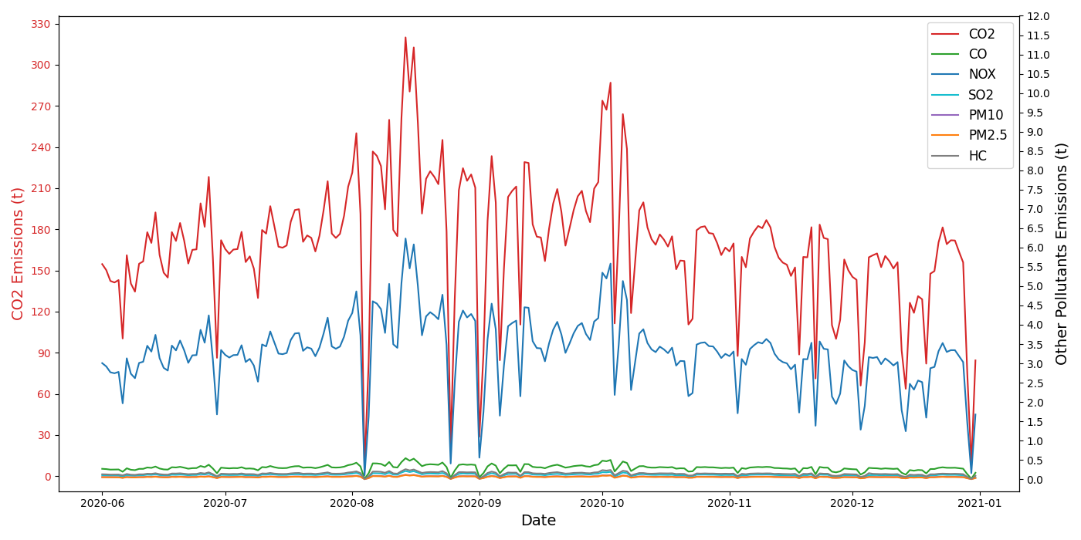

Figure 2.2 Passenger ship emissions vary over time (Note: The left axis represents CO2 emissions, and the right axis represents emissions of other pollutants

### 2.2.4 Emission Distribution Across Different Time Periods

To illustrate the daily emission trends of passenger ships from early morning to late night, a day is divided into 12 different time segments with two-hour intervals. It can be observed that 8:00-10:00, 10:00-12:00, and 14:00-16:00 are the three peak emission periods within a day, during which the concentrations of air pollutants are relatively high. The CO2 emissions during these periods account for 18.65%, 17.68%, and 18.32% of the total emissions, respectively. There is a significant reduction in the emissions of atmospheric pollutants from passenger ships during the day and night, with nighttime emissions constituting only 5.52%.

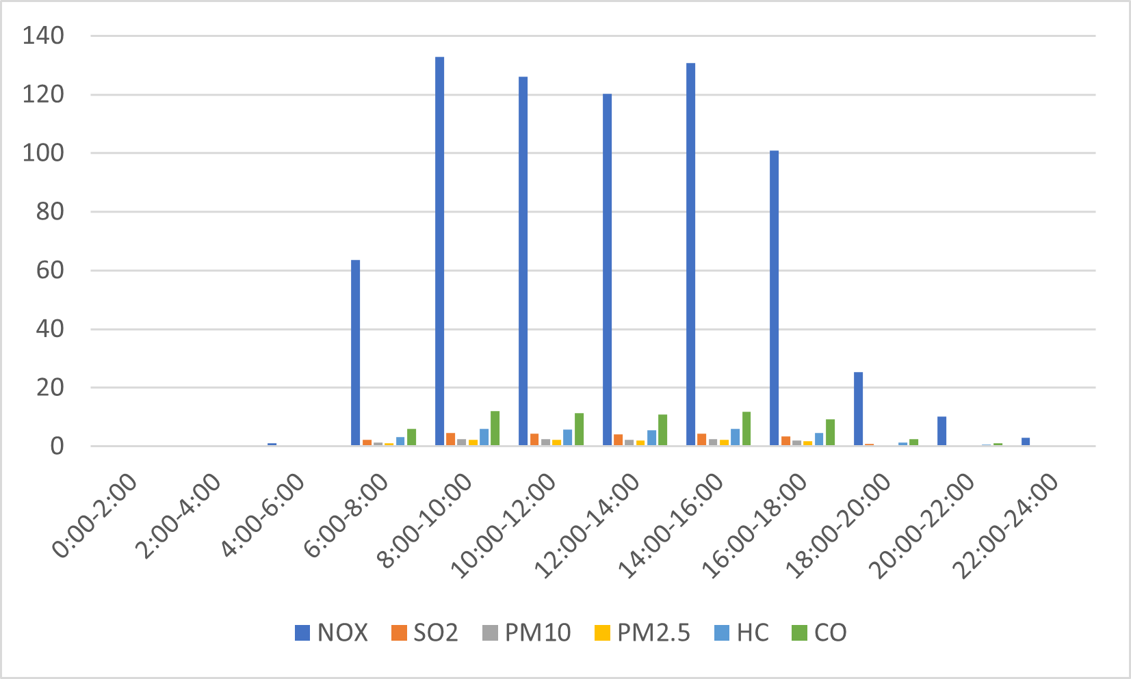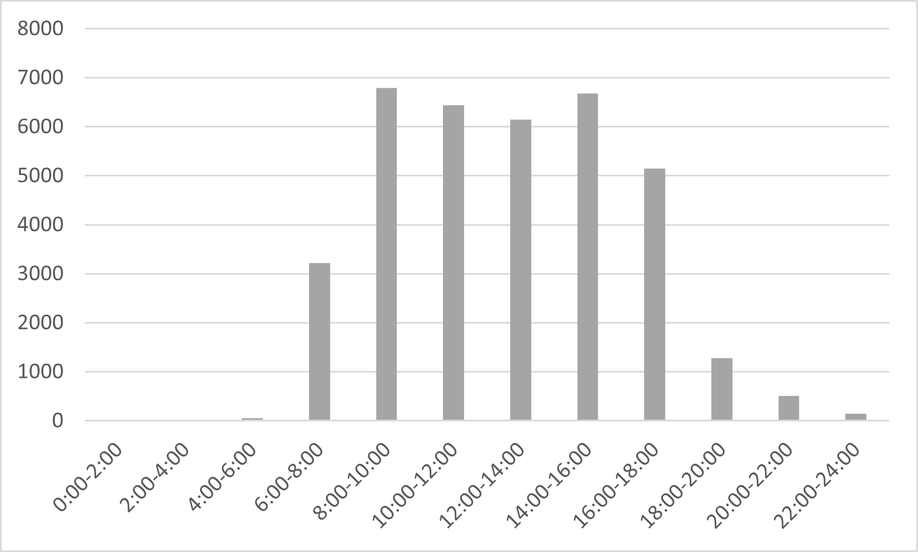

Figure 2.3 Different time periods of pollutant emission distribution, with CO2 emissions on right side

### 2.2.5 Different types of passenger ships' contribution to emissions

The contribution of emissions from different types of passenger ships is shown in Figure 2.4. The high-speed passenger ship has the largest proportion of emissions, followed by the ro-ro passenger ship, which has an average main engine power comparable to that of high-speed passenger ships, but carries far more passengers and vehicles than high-speed passenger ships. At the same time, it has the largest total tonnage of the ship, contributing nearly 40% of the total pollutant emissions. The regular passenger ship has the largest passenger capacity and, despite bearing the main burden of carrying passengers, accounts for only about 14% of emissions. The car ferry has the least emissions, with CO2 emissions amounting to only 489.15 tons.

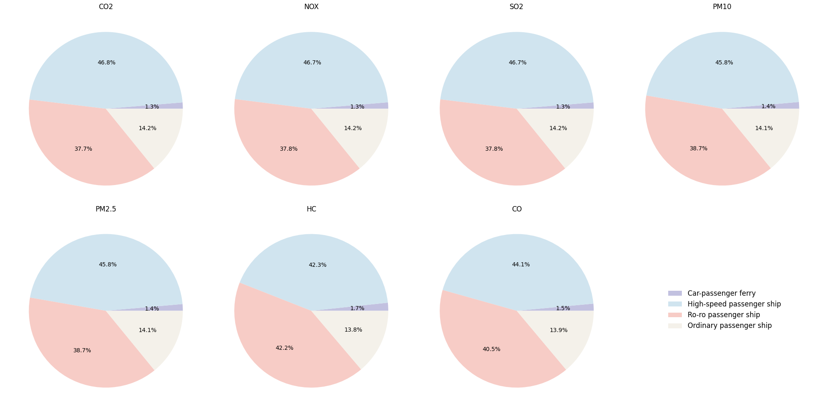

Figure 2.4 The contribution of emissions from different types of passenger ships of right side

### 2.2.6 The emission share of passenger ships in different operational modes

Based on previous research, we have divided the emissions of passenger ships in the Ningbo Zhoushan area into four operating modes: berthing, anchoring, maneuvering, and cruising, with the emission results shown in Figure 2.5. Compared to other types of ships, such as merchant ships, tankers, fishing vessels, etc., the exhaust gases produced by passenger ships during the cruising phase account for 97%-99% of all emissions.

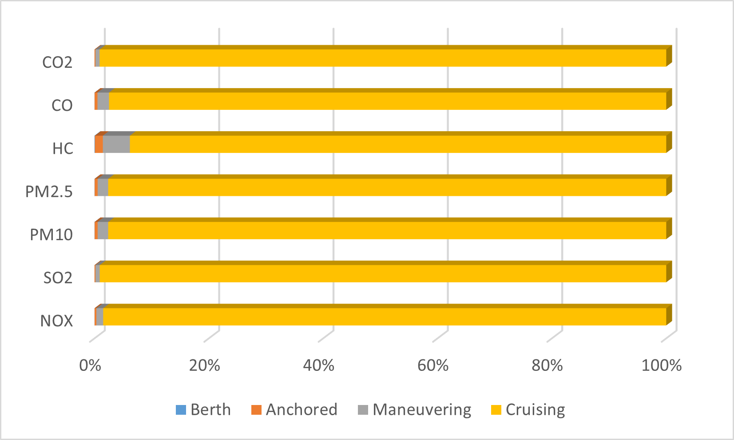

Figure 2.5 Emission Proportion Chart for Different Operating Modes

### 2.2.7 The impact of adverse weather conditions

Around certain dates, there are noticeable fluctuations in emissions, which we believe are due to the impact of typhoons and adverse weather conditions. The competent authorities issue early warnings for the areas under their jurisdiction, and various passenger ferry terminals on the island routes take measures such as suspending operations or implementing temporary emergency plans according to the meteorological conditions. This leads to a rapid decrease in passenger ship emissions, causing fluctuations. The specific times of impact are shown in Table 2.1. The lowest point of passenger ship emissions corresponds to the time of the adverse weather, which coincides with it.

Table 2.1 Cold waves and strong winds affecting the Zhoushan area from June to December 2020

|  |  |  |
| --- | --- | --- |
| Typhoon number | Typhoon name | Impact dates |
| 2004 | Hagupit | 8.03-8.05 |
| 2008 | Bavi | 8.25-8.26 |
| 2009 | Maysak | 9.01-9.02 |
| 2010 | Haishen | 9.05-9.06 |

### 2.2.8 Passenger ship trajectory distribution

By compiling and mapping the AIS data of passenger ships over seven months, the numerous islands in the Ningbo Zhoushan area have formed multiple commonly used shipping routes. The distinct paths in the trajectory map reflect the importance of these inter-island routes. In the trajectory map, areas with dense ship traffic typically avoid shallow banks and tidal flats. Specific maritime areas may have different functional divisions, such as fishing areas, aquaculture areas, and shipping lanes. Passenger ships need to navigate around these areas when sailing, and these areas can influence the layout of the shipping routes and the trajectories of the passenger ships.

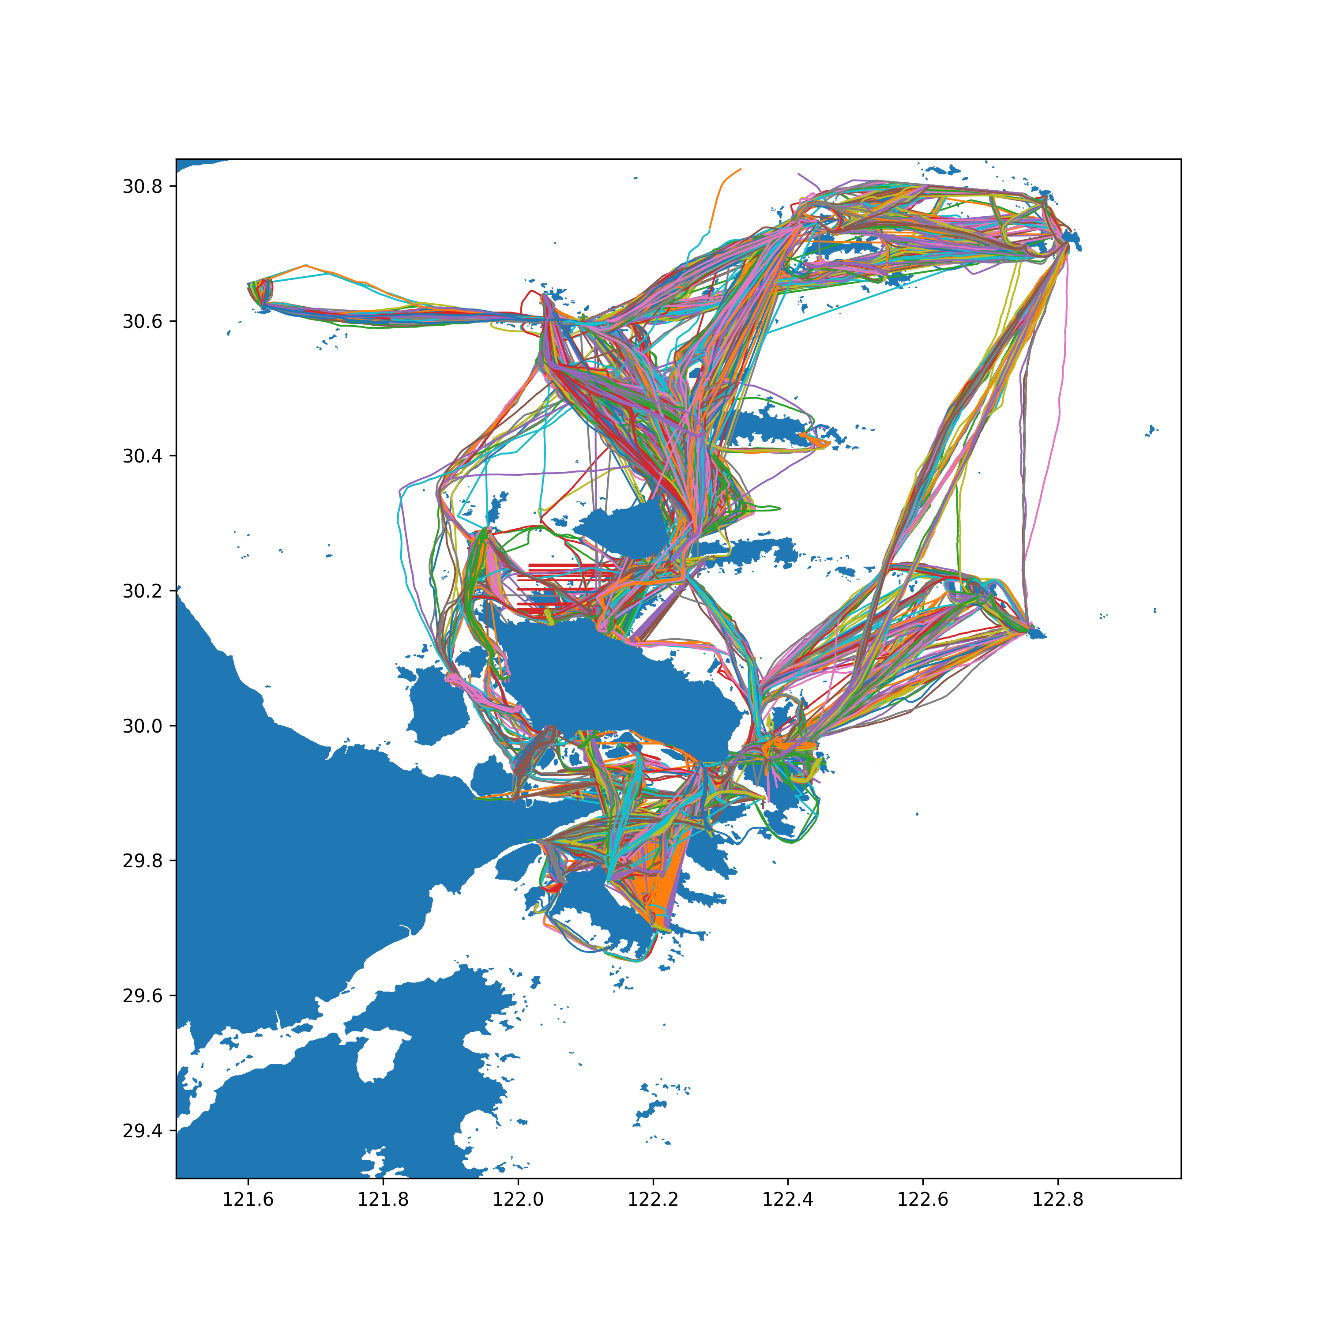

Figure 2.6 Passenger Ship Trajectory Map

### 2.2.9 Spatial Distribution of Passenger Ship Emissions

By gridding the area with a mesh size of 0.002° by 0.002° and aggregating and distributing the emissions of polluting gases into different units, the overall emission heatmap for June to December is obtained, as shown in Figure 2.7. It can be seen that the emission footprint from the shipping routes between Daishan Island, Qishan Island, and the Shengsi Islands is significantly larger than that of other areas. In addition, the traffic between Zhoushan Main Island, Liuheng Island, Xiazhi Island, and Taohua Island is also very frequent.

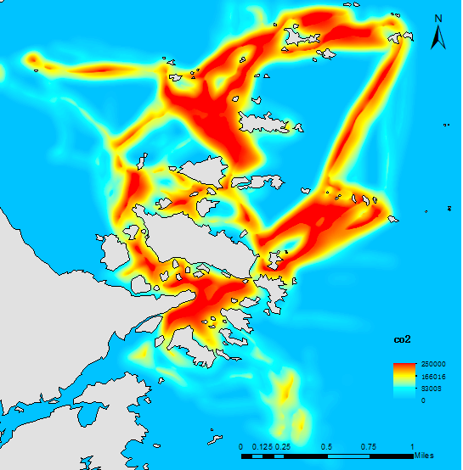

Figure 2.7 Emission Heatmap

## 2.3 Current Research Achievements

Currently, no small papers have been published, nor have any research patents or other research achievements been obtained.

# 3 Expected Problems and Solutions

This chapter is recommended to be arranged according to the following content (specific chapter titles, content, etc. are not limited and can be adjusted according to actual situations):

## 3.1 Current and expected issues that may arise

(1) The current research results only include emission data from June to December 2020, which does not allow for an analysis of the annual emission changes, especially the impact of winter cold waves and the Spring Festival holiday.

(2) The emission heatmap still needs optimization, as the contrast between high and low emission areas is not distinct.

(3) The emission trajectories and heatmaps for different types of passenger ships have not been separated.

## 3.2 Solution

(1) Continue to estimate the emissions of passenger ships from January to May 2021, and compare the emission data for the 12 months and 4 quarters of the year.

(2) Optimize the emission heat map and find suitable interpolation functions.

(3) Generate emission files for different types of passenger ships while running the code, and draw them separately.

**4 Next Step Work Plan**

|  |  |  |  |
| --- | --- | --- | --- |
| **Start and End Dates** | **Main Research Content** | **Expected Goals** | **Expected Outcomes and Formats** |
| July-September 2024 | Calculation of the Zhoushan area passenger ship emission inventory based on AIS data | Completion of the emission inventory for January-May | Chapter 4 of the thesis |
| October-December 2024 | Spatiotemporal characterization and analysis of passenger ship emissions in the Zhoushan area | Completion of the first draft of the thesis | First draft of the thesis |
| January-March 2025 | Collect feedback from supervisors and experts for revision and improvement | Revision and finalization of the thesis | Thesis revision suggestion list and final thesis draft |
| April-June 2025 | Prepare defense PPT based on the graduation thesis | Preparation for thesis defense and subsequent work | Defense PPT |
| July-September 2024 | Calculation of the Zhoushan area passenger ship emission inventory based on AIS data | Completion of the emission inventory for January-May | Chapter 4 of the thesis |

# References

[1] Guangxi Zhuang Autonomous Region Forestry Department. Guangxi Nature Reserves [M]. Beijing: China Forestry Publishing House, 1993: 45-47.2 Journal-derived literature

[2] Jiang Youxu, Guo Shuiquan, Ma Juan. Classification of Chinese Forest Communities and Their Syllogeographical Characteristics [M]. Beijing: Science Press, 1998: 23-30.

[3] International Federation of library Association and Institutions. Names of persons: national usages for entry in catalog [M]. 3rd ed. London: IFLA International office for UBC, 1977: 56-70.

[4] Arais D.J., Strauss H., Summons R.E.. Carbon isotope evidence for the stepwise oxidation of the Proterozoic environment [J]. Nature, 1992, 359(1): 605-609.4 Literature extracted from monographs